AREA AND CIRCUMFERENCE OF CIRCLES
Pearson Edexcel - Thursday 4 June 2020 - Paper 2 (Calculator) Foundation Tier

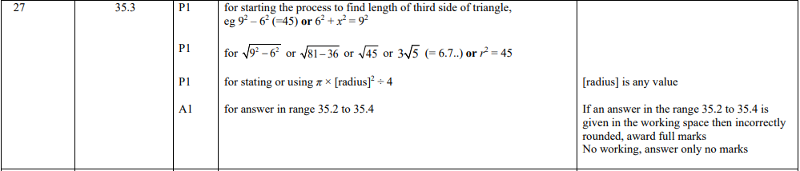

Pearson Edexcel - Thursday 24 May 2018 - Paper 1 (Non-Calculator) Foundation Tier

Pearson Edexcel - Thursday 7 June 2018 - Paper 2 (Calculator) Foundation Tier

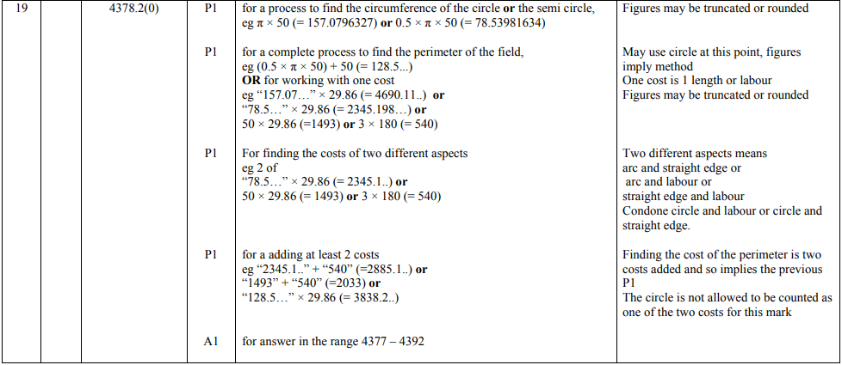

Pearson Edexcel - Thursday 2 November 2017 - Paper 1 (Non-Calculator) Foundation Tier

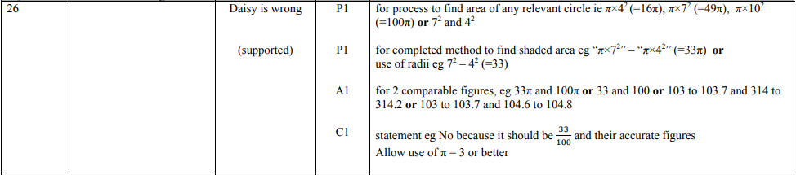

Pearson Edexcel - Monday 6 November 2017 - Paper 2 (Calculator) Foundation Tier

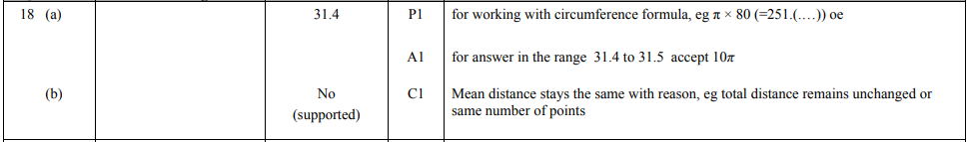

OCR – Tuesday 03 November 2020- Morning - Paper 1 (Calculator) Foundation Tier
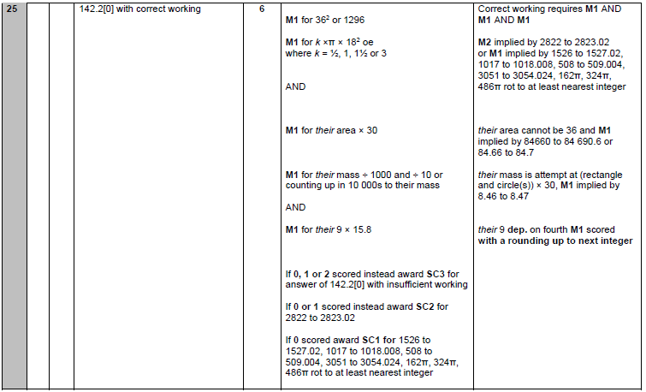

OCR Thursday 05 November 2020- Morning (Non-Calculator) Foundation Tier
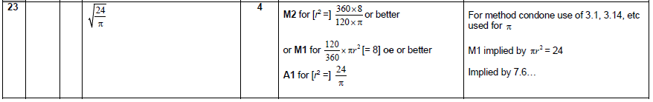

OCR Monday 11 November 2019 – Afternoon (Calculator) Foundation Tier
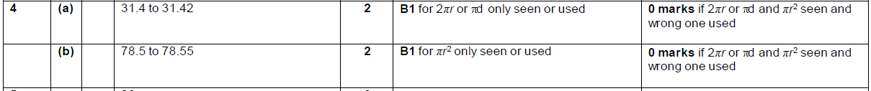

OCR Tuesday 21 May 2019 – Morning (Calculator) Foundation Tier

OCR Tuesday 6 November 2018 – Morning (Calculator) Foundation Tier

OCR Thursday 8 November 2018 – Morning (Non-Calculator) Foundation Tier

OCR Monday 24 May 2018 – Morning (Calculator) Foundation Tier
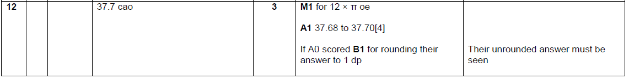

OCR Thursday 7 June 2018 – Morning (Non Calculator) Foundation Tier
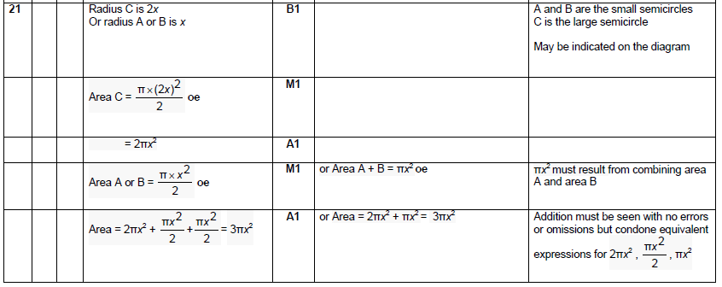

OCR Monday 6 November 2017– Morning (Calculator) Foundation Tier

AQA Tuesday 19 May 2020 – Morning (Non-Calculator) Foundation Tier

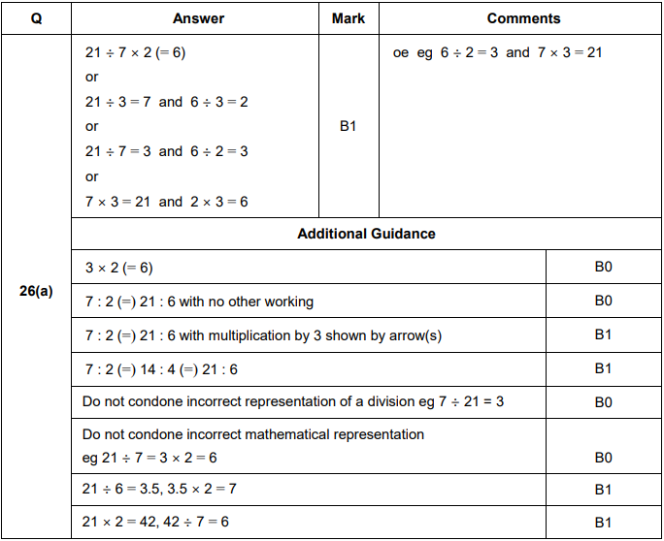
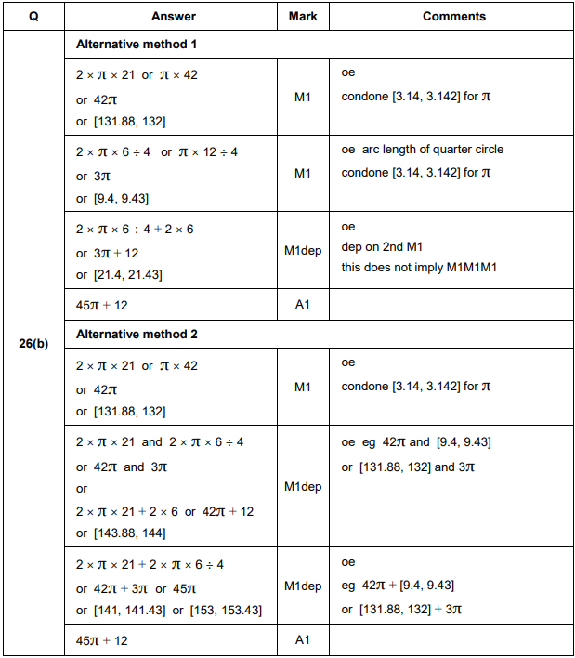

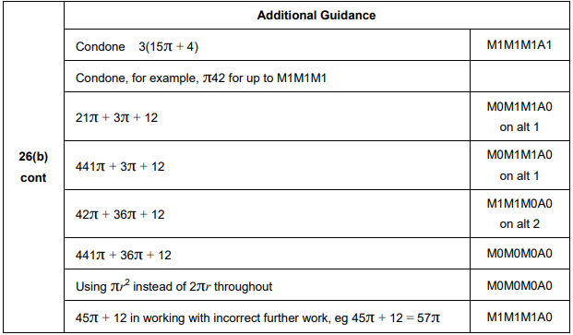
AQA Thursday 4 June 2020 – Morning (Calculator) Foundation Tier

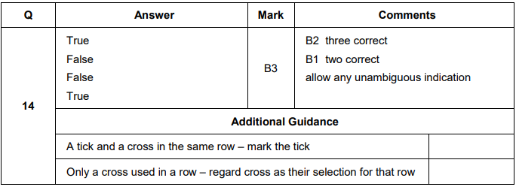

AQA Thursday 8 November 2018 – Morning (Calculator) Foundation Tier

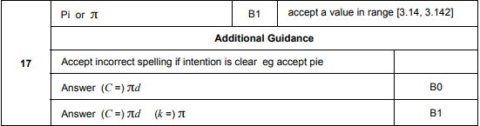
AQA Thursday 7 June 2018 – Morning (Calculator) Foundation Tier

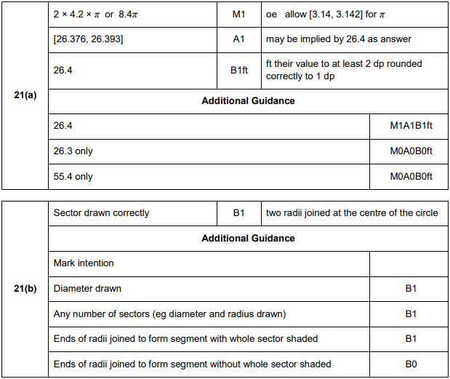

AQA Thursday 2 November 2017 – Morning (Non-Calculator) Foundation Tier

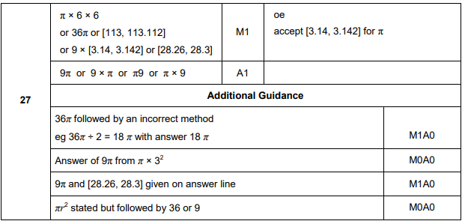
AQA Thursday 25 May 2017– Morning (Non-Calculator) Foundation Tier

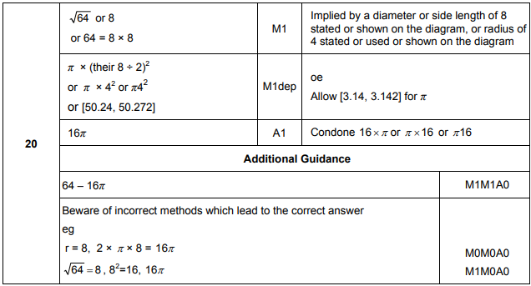

AQA Tuesday 13 June 2017 Morning– Morning (Calculator) Foundation Tier

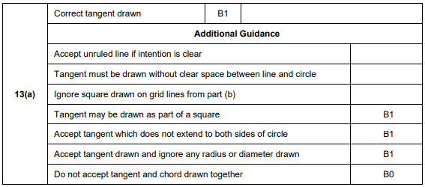
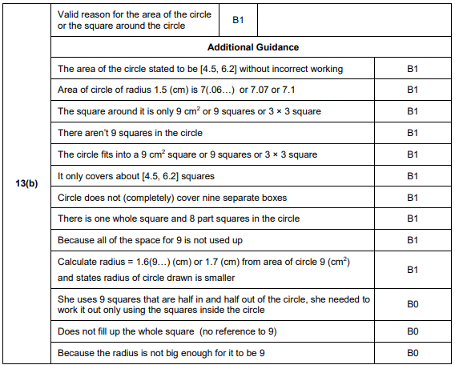

AQA Sample Paper 1– Morning (Non-Calculator) Foundation Tier

